**TEAMNAME:BusyBees**

**DEEPLEARNING 2/Section 1:**

**ScreenShots**

1)Take the article dataset from kaggle and Load the dataset in colab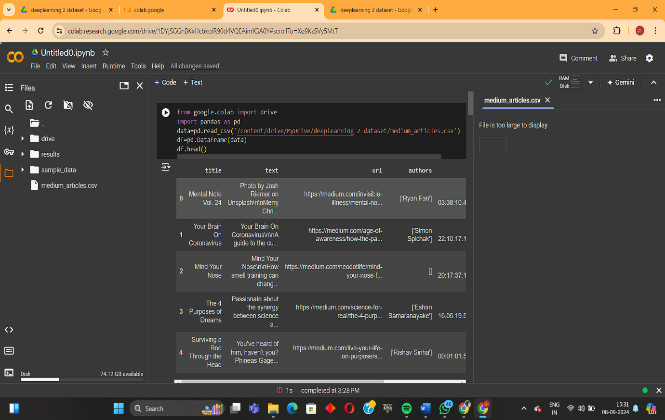

2)Install required libraries for extractive summarization

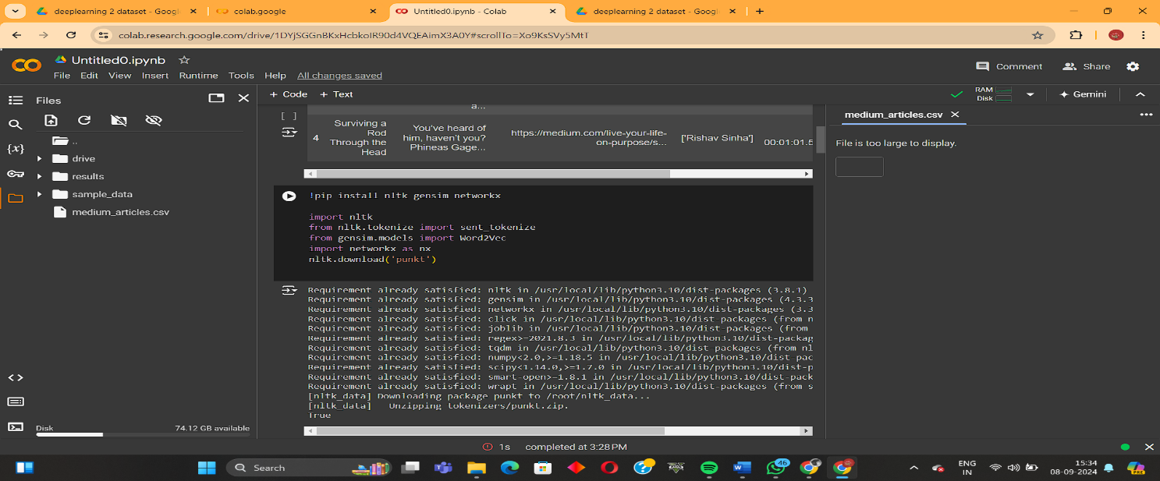

3)Fine tuning the language models

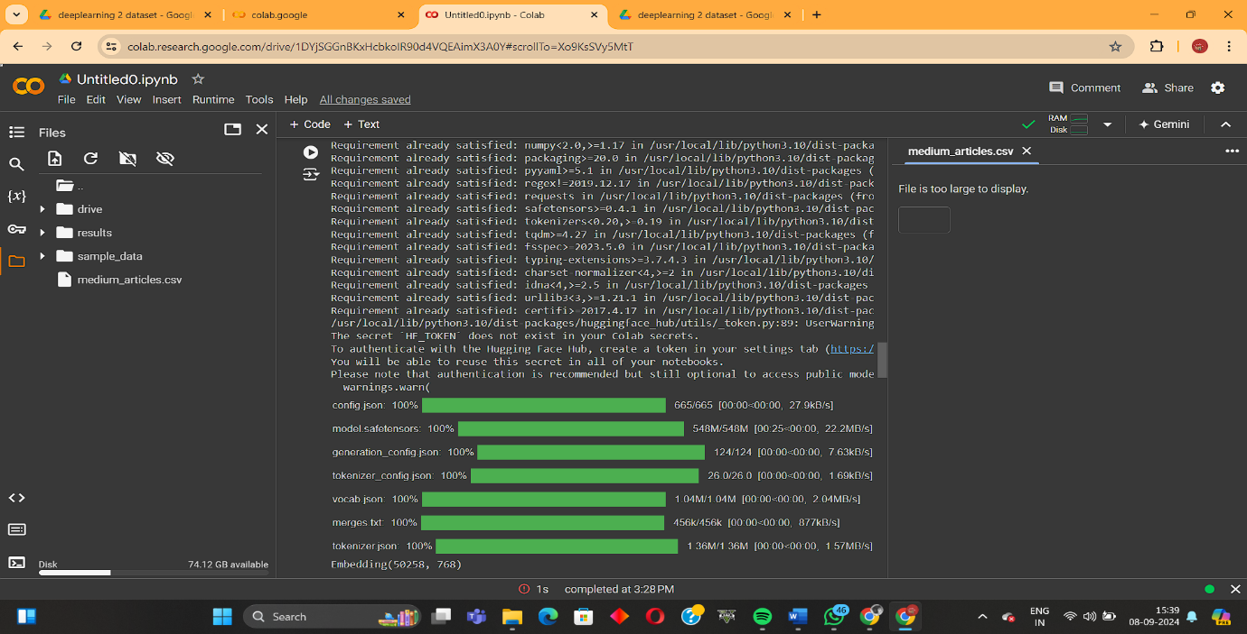

4)Prepare the dataset for finetuning

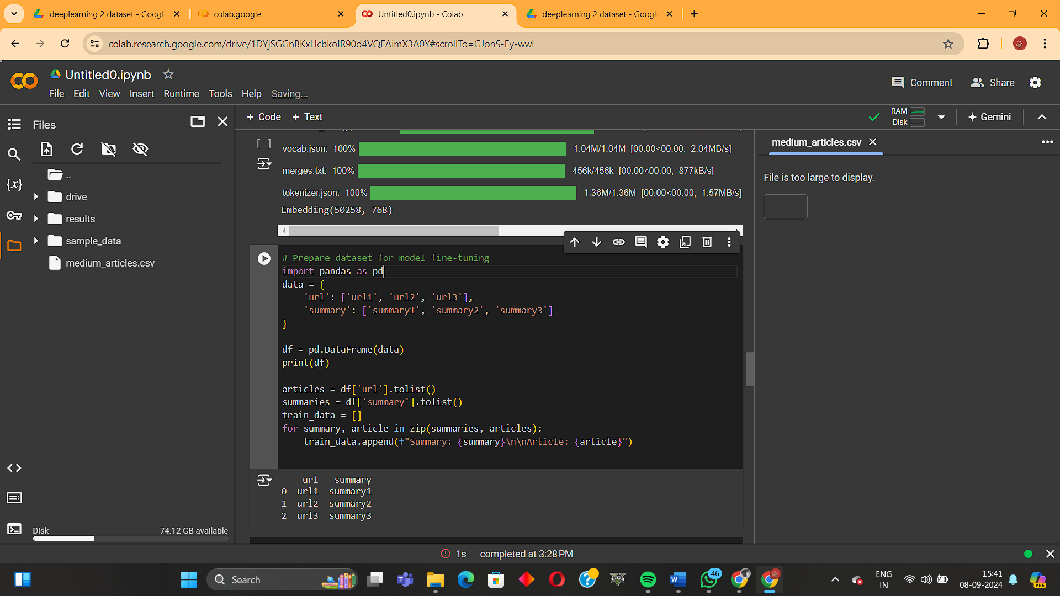

5)Fine tune the model

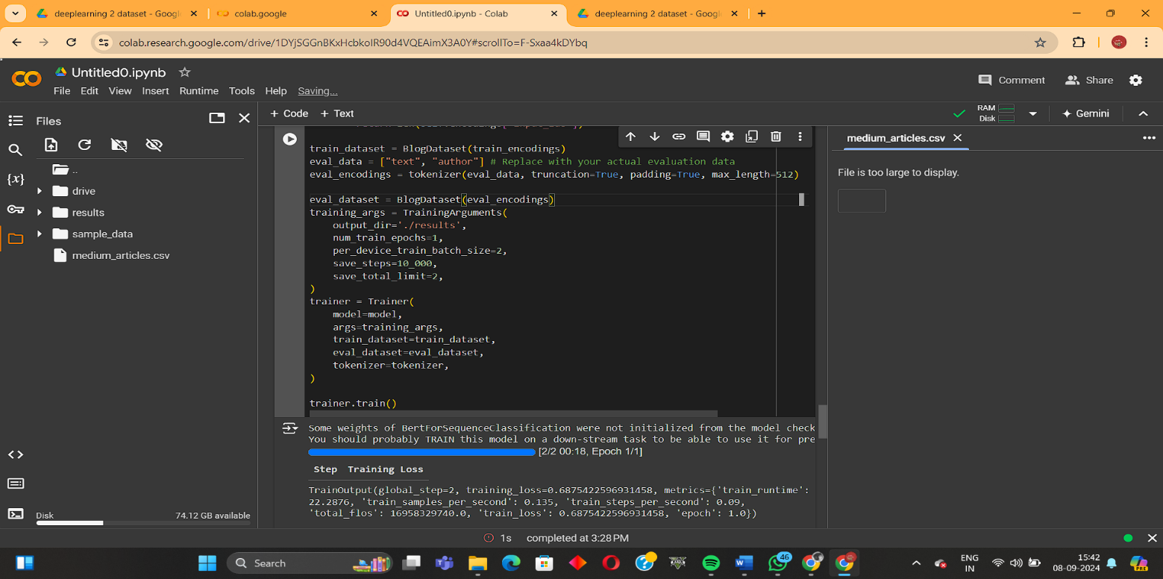

6)Test the blog

